

Preliminary Report – Bradford Island Picket Lead Video – 12 July 2012
To: Sean Tackley, Portland District USACE.
From: Christopher Caudill, Tami Clabough, Eric Johnson, Dan Joosten, and Christopher Noyes
This is a preliminary summary for the University of Idaho Bradford Island Picket Lead Video study at Bonneville Dam. Our objective was to determine whether adult salmonids (Oncorhynchus spp.) attempted to enter the auxiliary water supply (AWS) channel by passing under the picket lead, which has been raised slightly to increase Pacific lamprey (Entosphenus tridentatus) access to the LPS.
Three underwater cameras were deployed upstream of the picket lead gate in the Bradford Island fish ladder. Two cameras (cameras 2 and 3; see Figure 1) monitored a picket lead raised approximately an inch off the fishway floor in the auxiliary water supply channel and one camera (camera 1) monitored a picket lead near the count window which was not raised.
We reviewed eight hours of video out of ~16 daylight hours collected on June 25 at camera 3 and four hours of video at camera 2 (June 25). Every other hour was viewed from 0530-2130 h. This date was the peak (16, 964; Figure 2) of the sockeye salmon (O. nerka) run, with 16,964 adults counted at the Bradford Island fishway along with 796 Chinook salmon (O. tshawytscha) and 155 steelhead (O. mykiss). Two Pacific lamprey were observed moving downstream at camera 2 and lamprey were found attached to the picket lead gate by camera 1 (during review of short 1-2 minute video clips).
No adult salmonids of any species were observed during the viewing period. Peamouth (Mylocheilus caurinus) and salmonid smolts were prevalent during each hour of viewing but were not quantified due to their near constant presence in front of the camera and milling behavior in the range of the camera. Water clarity was poor to medium due to debris in the water. Therefore, fish identification was difficult for a small percentage of fish that did not swim in close proximity to the camera (based on size, these fish were not adult salmonids). These preliminary results suggest that adult salmonids, including relatively small-bodied sockeye salmon, jack Chinook salmon, and steelhead, did not attempt to enter the auxiliary water supply (AWS) channel at Bradford Island during the viewing period.

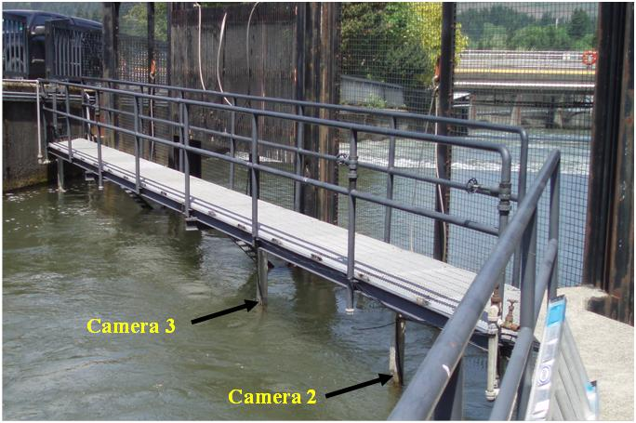
Figure 1. Configuration of underwater cameras deployed in the auxiliary water channel in Bradford Island fish ladder at Bonneville Dam in 2012. Note camera one is not shown.

Figure 2. Bradford Island sockeye salmon count at Bonneville Dam in 2012.

